

Health History and Questionnaire

**Patient Name:** ______________________________________

**History of problem for which you’re being seen:**

Reason for exam:_______________________________________________________________

Type of injury:  Job  Accident  Sports injury  Other ______________________

Date of injury:________________

Do you have cancer?  Yes  No Cancer Type/Stage:__________________________

On the diagram below put an “**x”** where it hurts the most; check all items that apply

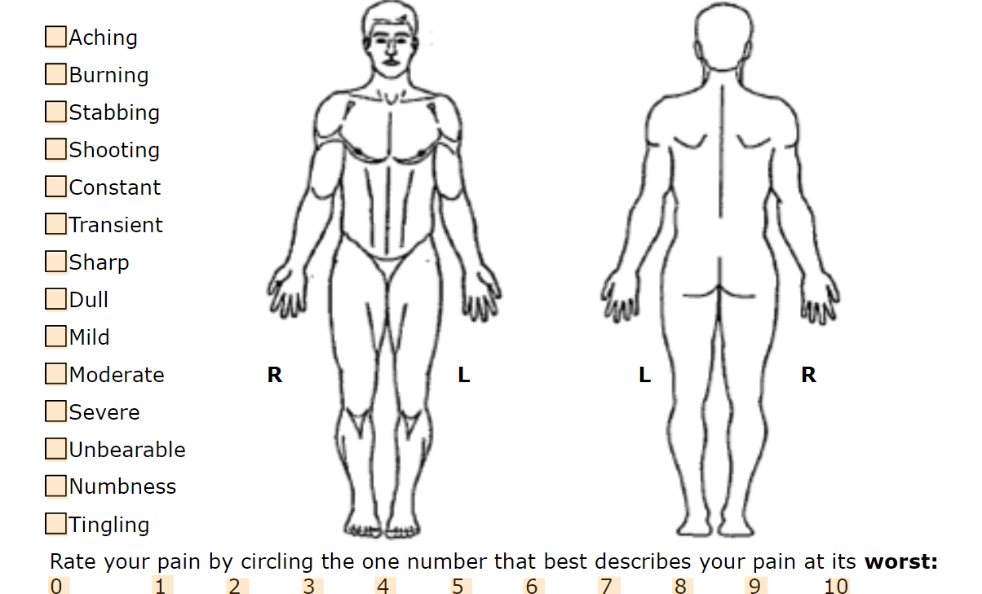

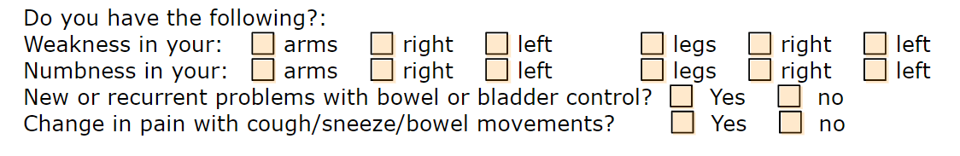

**Prior imaging, check all items that apply:**



**PET**

Initial Staging YES NO

Subsequent Staging YES NO